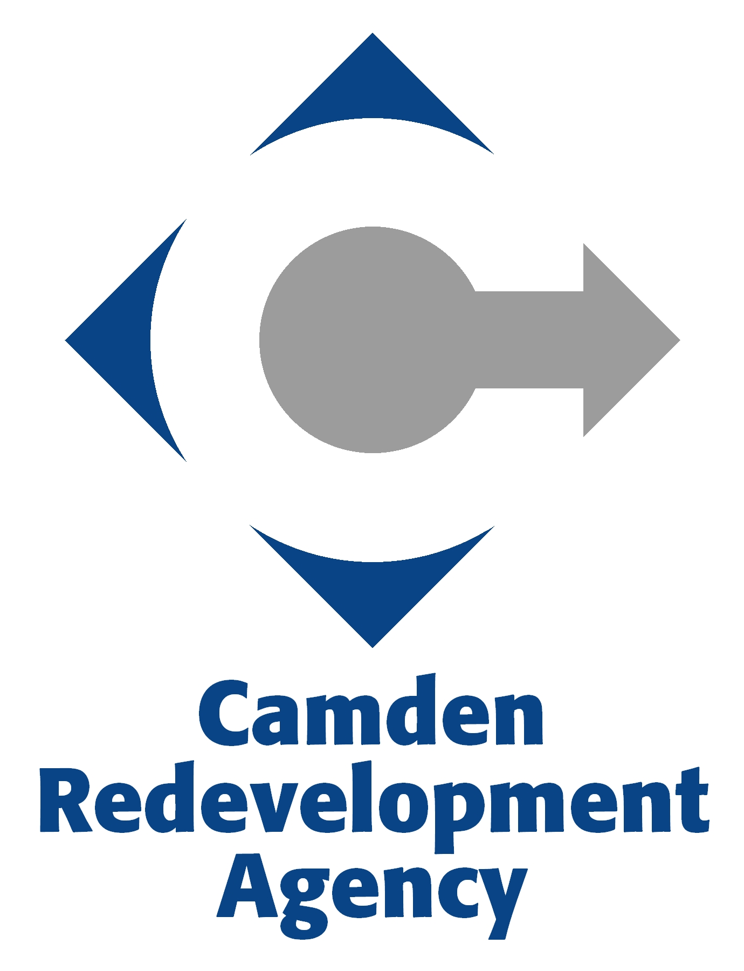

PUBLIC MEETING NOTICE
The Camden Redevelopment Agency Board of Commissioners’ Caucus will be held on Wednesday, January 9, 6:00 PM, at City Hall, Camden, NJ 08101.

AGENDA
January 9, 2013
6:00 PM
I. Call to Order - Chairperson
II. Roll Call - Board Clerk
III. Statement of Compliance with Open Public Meetings Act
IV. Review of Minutes
V. Review of Executive Director's Report
VI. Review of Resolutions

01-16-13A Resolution Authorizing

01-16-13B Resolution Authorizing

VII. Public Comments

VIII. Chairperson's Remarks and Observations

IX. Old Business

X. New Business

XI. Executive Session

XII. Adjournment

