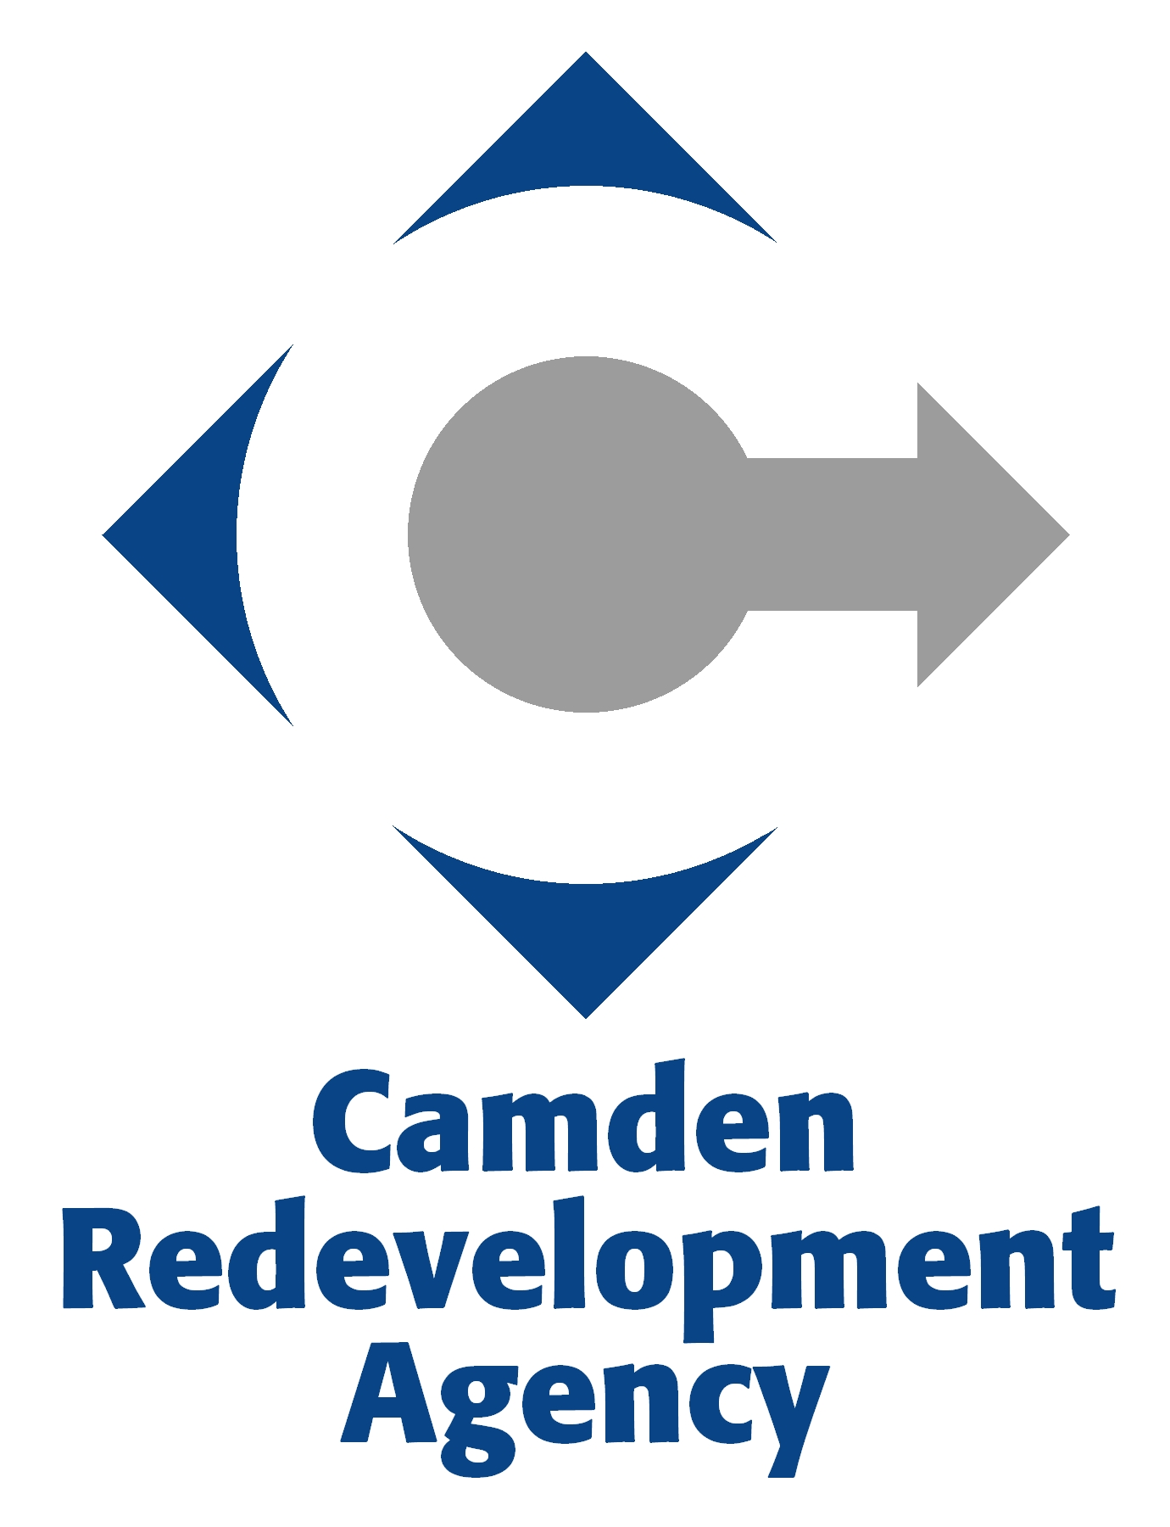

PUBLIC HEARING

The Camden Redevelopment Agency will conduct a public hearing to discuss
the Fiscal Year End 2012 Budget, on Thursday, December 29, 2011 at 4:30 PM.
At 5:30 PM, the Camden Redevelopment Agency will conduct a Special Board Meeting to adopt the Fiscal Year End 2012 Budget. Both meetings will be held
at 520 Market Street, Suite 1300, Camden, NJ in the Conference Room.

