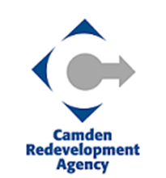
CITY OF CAMDEN REDEVELOPMENT AGENCY
BOARD OF COMMISSIONERS MEETING
CITY HALL, 520 MARKET STREET
CAMDEN, NEW JERSEY

May 1, 2024 BOARD CAUCUS
CANCELATION NOTICE

The CRA Board Caucus meeting scheduled for Wednesday, May 1, 2024 has been canceled.

The Board will meet at its Regular Meeting
via Teleconference at 6:00pm, on
Wednesday, May 1, 2024.

Thank you.

